# WEEK 5: DYNAMIC PROGRAMMING

### PROGRAM 1:

**AIM:** Ram and Sita are playing with numbers by giving puzzles to each other. Now it was Ram term, so he gave Sita a positive integer ‘n’ and two numbers 1 and 3. He asked her to find the possible ways by which the number n can be represented using 1 and 3.Write any efficient algorithm to find the possible ways.

### ALGORITHM:

Step 1: Start

Step 2: Declare n and read input value

Step 3: Create an array dp of size n + 1, initialize dp[0] to 1, and set all other elements to 0

Step 4: Iterate from 1 to n, updating dp[i] by adding dp[i - 1]. If i is greater than or equal to 3, also add dp[i - 3] to dp[i]

Step 5: Print the value dp[n] Step 6: End

**PROGRAM:**

#include<stdio.h> int main()

{

int n; scanf("%d", &n); long dp[n+1]; dp[0] = 1;

for (int i = 1; i <= n; i++) { dp[i] = 0;

}

for (int i = 1; i <= n; i++) { dp[i] += dp[i - 1];

if (i >= 3) {

dp[i] += dp[i - 3];

}

}

printf("%ld\n", dp[n]); return 0;

}

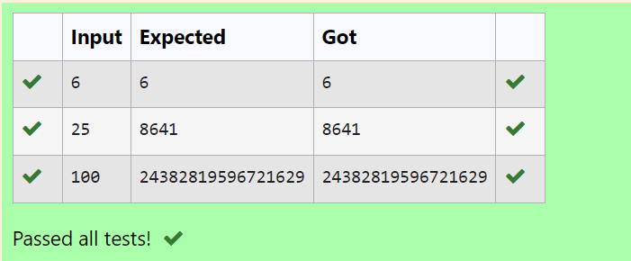

**RESULT:** Thus the program is executed successfully.

### PROGRAM 2:

**AIM:** Ram is given with an n*n chessboard with each cell with a monetary value. Ram stands at the (0,0), that the position of the top left white rook. He is been given a task to reach the bottom right black rook position (n-1, n-1) constrained that he needs to reach the position by traveling the maximum monetary path under the condition that he can only travel one step right or one step down the board. Help ram to achieve it by providing an efficient DP algorithm.

### ALGORITHM:

Step 1: Start

Step 2: Declare n, read input value, and create a 2D array board of size n x n to store its values Step 3: Initialize dp[0][0] with board[0][0], populate the first row and column of dp by accumulating values from board

Step 4: Iterate through the remaining cells of the dp array, updating each cell with the maximum path sum from either the top or left cell, and board[i][j]

Step 5: Print the value dp[n-1][n-1]

### PROGRAM:

#include<stdio.h> int max(int a,int b) {

return(a>b) ? a:b;

}

int maxMonetaryPath(int n,int board[n][n]){ int dp[n][n];

dp[0][0]=board[0][0]; for(int j=1;j<n;j++){

dp[0][j]=dp[0][j-1]+board[0][j];

}

for (int i=1;i<n;i++) { dp[i][0]=dp[i-1][0]+board[i][0];

}

for (int i=1;i<n;i++) { for (int j=1;j<n;j++) {

dp[i][j]=board[i][j]+max(dp[i-1][j],dp[i][j-1]);

}

}

return dp[n-1][n-1];

}

int main(){

int n; scanf("%d",&n);

int board[n][n];

for (int i=0;i<n;i++){ for (int j=0;j<n;j++){

scanf("%d",&board[i][j]);

}

}

int result=maxMonetaryPath(n,board); printf("%d\n",result);

}

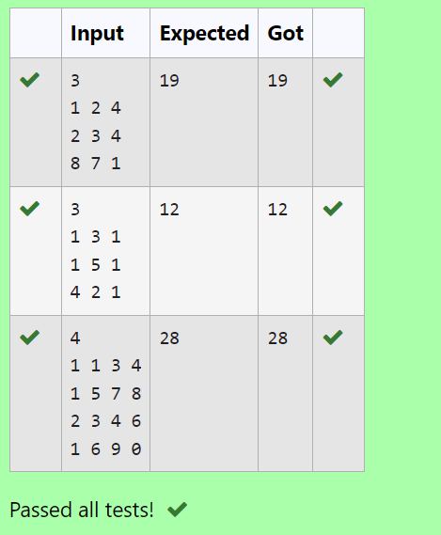**OUTPUT:**

**RESULT:** Thus the program is executed successfully.

## PROGRAM 3:

**AIM:** Given two strings find the length of the common longest subsequence(need not be contiguous) between the two.

### ALGORITHM:

Step 1: Start

Step 2: Declare s1 and s2 as character arrays and read the input values

Step 3: Calculate the lengths of s1 and s2, and create a 2D array dp of size (len1 + 1) x (len2 + 1)

Step 4: Initialize the first row and column of dp to 0, then iterate through the arrays to fill dp by comparing characters of s1 and s2 and taking the maximum of the adjacent values

Step 5: Print dp[len1][len2]

### PROGRAM:

#include<stdio.h> #include<string.h>

int main()

{

char s1[10],s2[10];

scanf("%s",s1);

scanf("%s",s2);

int len1=strlen(s1); int len2=strlen(s2);

int dp[len1 + 1][len2 + 1]; for(int i=0;i<=len1;i++)

{

for(int j=0;j<=len2;j++)

{

if(i==0||j==0)

{

dp[i][j]=0;

}

else if(s1[i-1]==s2[j-1]){

dp[i][j]=dp[i-1][j-1]+1;

}

else{

if(dp[i][j-1]>dp[i-1][j])

dp[i][j]=dp[i][j-1]; else

dp[i][j]=dp[i-1][j];

}

}

}

printf("%d",dp[len1][len2]);

}

### OUTPUT:

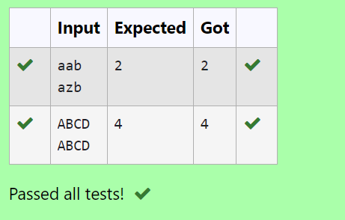

**RESULT:** Thus the program executes successfully.

### PROGRAM 4:

**AIM:** Find the length of the Longest Non-decreasing Subsequence in a given Sequence.

### ALGORITHM:

Step 1: Start

Step 2: Declare n, read the input value, and create an array arr of size n to store its values Step 3: Initialize a 1D array dp of size n with all elements set to 1, and a variable maxlen to 1 Step 4: Iterate through the array arr to ﬁll dp by comparing

elements, updating dp[i] if arr[i] is greater than or equal to arr[j] and dp[i] < dp[j] + 1, also update maxlen.

Step 5: Print maxlen.

### PROGRAM:

#include <stdio.h>

int subsequence(int arr[],int n){ int dp[n];

int maxlen=1;

for (int i=0;i<n;i++){ dp[i]=1;

}

for (int i=1;i<n;i++){ for(int j=0;j<i;j++){

if(arr[i]>=arr[j] && dp[i]<dp[j]+1){ dp[i]=dp[j]+1;

}

}

if(maxlen<dp[i]){ maxlen=dp[i];

}

}

return maxlen;

}

int main(){ int n;

scanf("%d",&n); int arr[n];

for (int i=0;i<n;i++){ scanf("%d",&arr[i]);

}

int result=subsequence(arr,n); printf("%d",result);

}

### OUTPUT

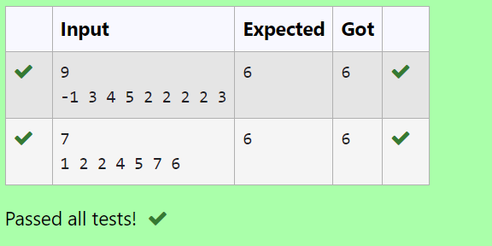

**RESULT:** Thus the program was executed successfully.